1. **Message display in command prompt**

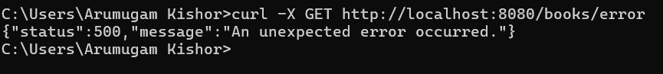

1. **Message display in Browser**

